7.2: a) For constant speed, the net force is zero, so the required force is the sack’s weight, 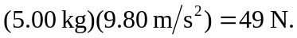 b) The lifting force acts in the same direction as the sack’s motion, so the work is equal to the weight times the distance, 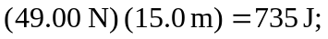 this work becomes potential energy. Note that the result is independent of the speed, and that an extra figure was kept in part (b) to avoid roundoff error.

